Step 1: When the cluster is active add the worker node group

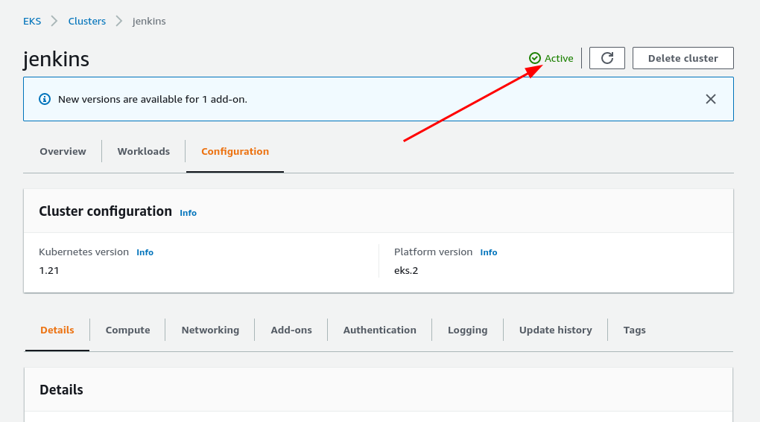

* Click on compute from below

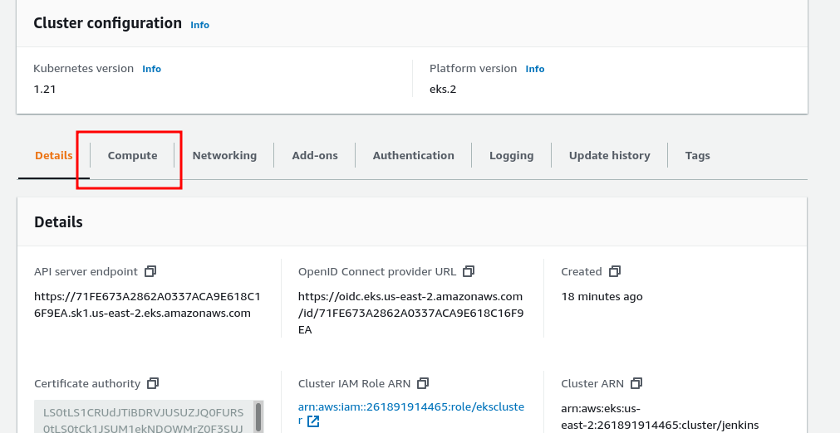

* Click on add node group

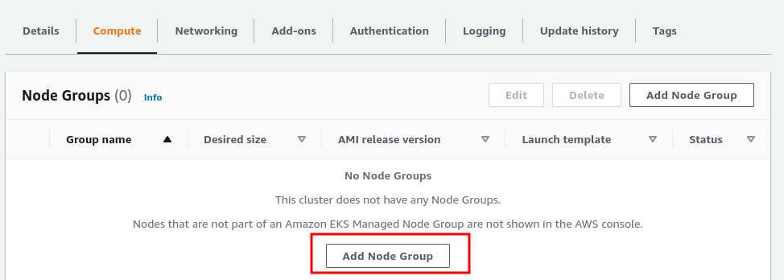

* Configure the node

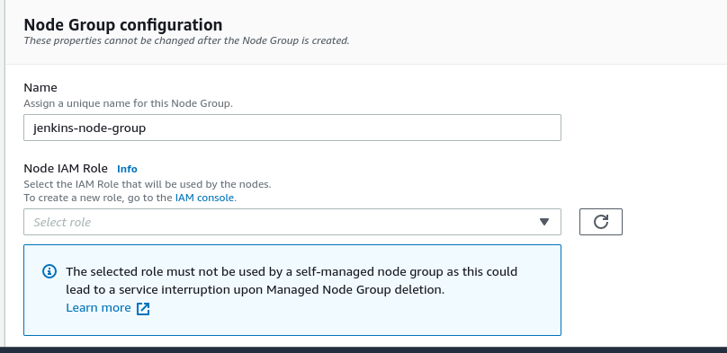

* For the role again go to IAM role and create a role for your node group
* Click on ec2

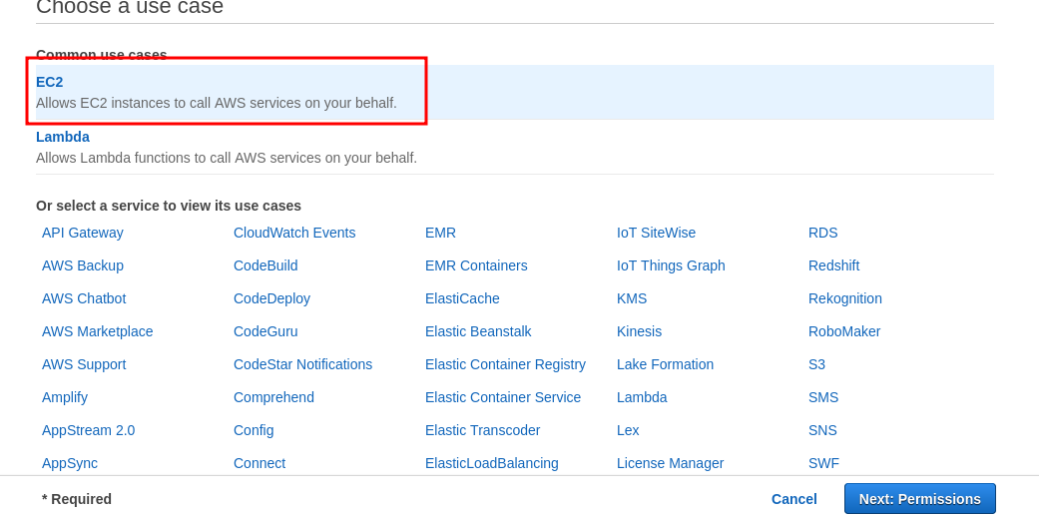

* Next permission
* Add [AmazonEKSWorkerNodePolicy](https://console.aws.amazon.com/iam/home#/policies/arn%3Aaws%3Aiam%3A%3Aaws%3Apolicy%2FAmazonEKSWorkerNodePolicy), [AmazonEC2ContainerRegistryReadOnly](https://console.aws.amazon.com/iam/home#/policies/arn%3Aaws%3Aiam%3A%3Aaws%3Apolicy%2FAmazonEC2ContainerRegistryReadOnly) ,[AmazonEKS_CNI_Policy](https://console.aws.amazon.com/iam/home#/policies/arn%3Aaws%3Aiam%3A%3Aaws%3Apolicy%2FAmazonEKS_CNI_Policy)
* Now Create the role

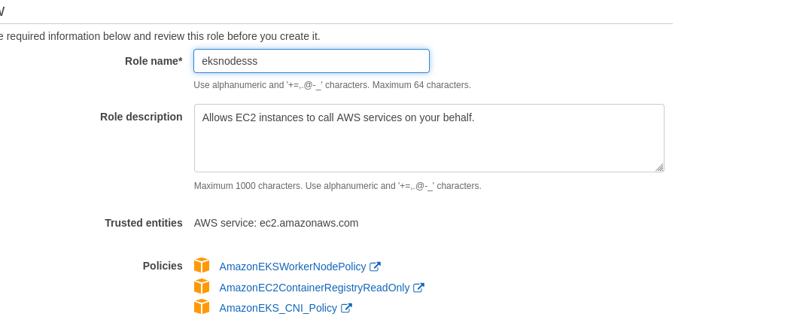

* Create the role and go back to work node group creation and select this role that is created

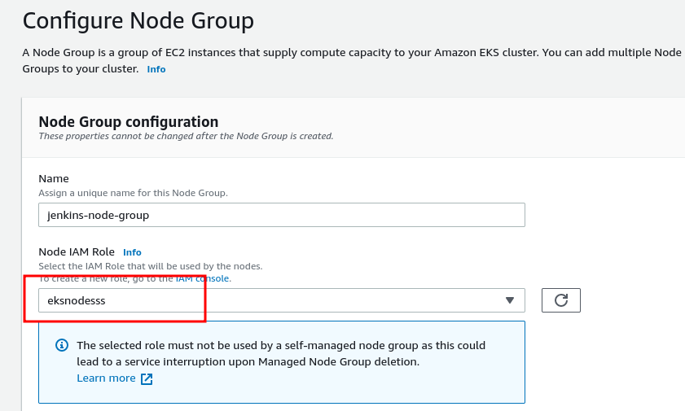

* Next and go to node scaling
* And make it 1 in minimum, maximum, and desired and leave everything on default and create

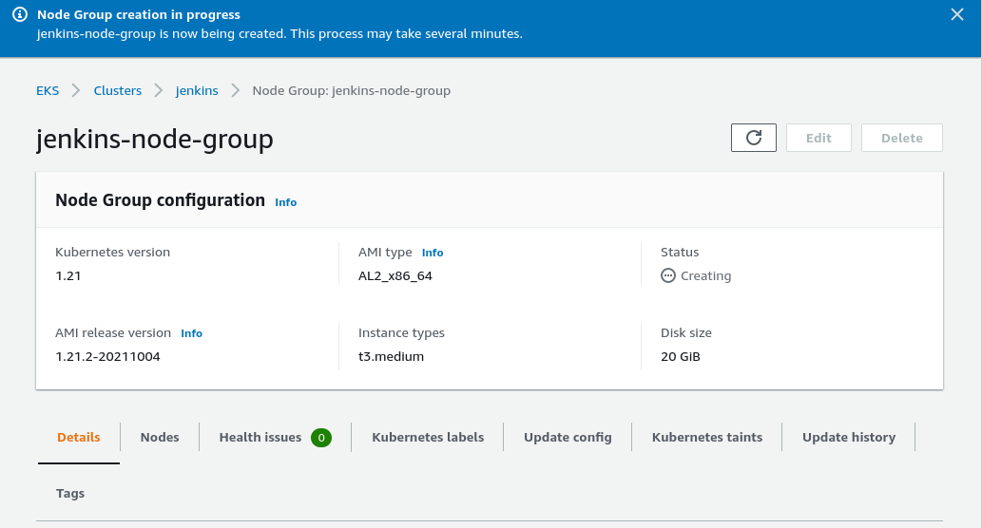

* It will take time to activate the node group wait for several minutes

